Title of the paper

1st Name & Surname, 2nd Name & Surname, 3rd Name & Surname

ABSTRACT

Lorem ipsum dolor sit amet, consectetur adipisicing elit, sed do eiusmod tempor incididunt ut labore et dolore magna aliqua. Ut enim ad minim veniam, quis nostrud exercitation ullamco laboris nisi ut aliquip ex ea commodo consequat. Duis aute irure dolor in reprehenderit in voluptate velit esse cillum dolore eu fugiat nulla pariatur. Excepteur sint occaecat cupidatat non proident, sunt in culpa qui officia deserunt mollit anim id est laborum. Lorem ipsum dolor sit amet, consectetur adipisicing elit, sed do eiusmod tempor incididunt ut labore et dolore magna aliqua. Ut enim ad minim veniam, quis nostrud exercitation ullamco laboris nisi ut aliquip ex ea commodo consequat. Duis aute irure dolor in reprehenderit in voluptate velit esse cillum dolore eu fugiat nulla pariatur. Excepteur sint occaecat cupidatat non proident, sunt in culpa qui officia deserunt mollit anim id est laborum. Lorem ipsum dolor sit amet, consectetur adipisicing elit, sed do eiusmod tempor incididunt ut labore et dolore magna aliqua. Ut enim ad minim veniam, quis nostrud exercitation ullamco laboris nisi ut aliquip ex ea commodo consequat. Duis aute irure dolor in reprehenderit in voluptate velit esse cillum dolore eu fugiat nulla pariatur. Excepteur sint occaecat cupidatat non proident, sunt in culpa qui officia deserunt mollit anim id est laborum.

Key words: Keyword1, Keyword2, Keyword3, Keyword4, Keyword5

JEL classification: JEL_Code1, JEL_Code 2, JEL_Code 3, JEL_Code 4, JEL_Code 5

- Introduction

Lorem ipsum dolor sit amet, consectetur adipisicing elit, sed do eiusmod tempor incididunt ut labore et dolore magna aliqua. Ut enim ad minim veniam, quis nostrud exercitation ullamco laboris nisi ut aliquip ex ea commodo consequat. Duis aute irure dolor in reprehenderit in voluptate velit esse cillum dolore eu fugiat nulla pariatur. Excepteur sint occaecat cupidatat non proident, sunt in culpa qui officia deserunt mollit anim id est laborum.

- Literature review

Lorem ipsum dolor sit amet, consectetur adipisicing elit, sed do eiusmod tempor incididunt ut labore et dolore magna aliqua. Ut enim ad minim veniam, quis nostrud exercitation ullamco laboris nisi ut aliquip ex ea commodo consequat. Duis aute irure dolor in reprehenderit in voluptate velit esse cillum dolore eu fugiat nulla pariatur. Excepteur sint occaecat cupidatat non proident, sunt in culpa qui officia deserunt mollit anim id est laborum

Lorem ipsum dolor sit amet, consectetur adipisicing elit, sed do eiusmod tempor incididunt ut labore et dolore magna aliqua. Ut enim ad minim veniam, quis nostrud exercitation ullamco laboris nisi ut aliquip ex ea commodo consequat. Duis aute irure dolor in reprehenderit in voluptate velit esse cillum dolore eu fugiat nulla pariatur. Excepteur sint occaecat cupidatat non proident, sunt in culpa qui officia deserunt mollit anim id est laborum.

- Methodology/Method/Model/Conception of analysis

Lorem ipsum dolor sit amet, consectetur adipisicing elit, sed do eiusmod tempor incididunt ut labore et dolore magna aliqua. Ut enim ad minim veniam, quis nostrud exercitation ullamco laboris nisi ut aliquip ex ea commodo consequat. Duis aute irure dolor in reprehenderit in voluptate velit esse cillum dolore eu fugiat nulla pariatur. Excepteur sint occaecat cupidatat non proident, sunt in culpa qui officia deserunt mollit anim id est laborum.

- Empirical data (documentation background) and analysis

Lorem ipsum dolor sit amet, consectetur adipisicing elit, sed do eiusmod tempor incididunt ut labore et dolore magna aliqua. Ut enim ad minim veniam, quis nostrud exercitation ullamco laboris nisi ut aliquip ex ea commodo consequat. Duis aute irure dolor in reprehenderit in voluptate velit esse cillum dolore eu fugiat nulla pariatur. Excepteur sint occaecat cupidatat non proident, sunt in culpa qui officia deserunt mollit anim id est laborum.

  - Second level heading

Lorem ipsum dolor sit amet, consectetur adipisicing elit, sed do eiusmod tempor incididunt ut labore et dolore magna aliqua. Ut enim ad minim veniam, quis nostrud exercitation ullamco laboris nisi ut aliquip ex ea commodo consequat. Duis aute irure dolor in reprehenderit in voluptate velit esse cillum dolore eu fugiat nulla pariatur. Excepteur sint occaecat cupidatat non proident, sunt in culpa qui officia deserunt mollit anim id est laborum.
Lorem ipsum dolor sit amet, consectetur adipisicing elit, sed do eiusmod tempor incididunt ut labore et dolore magna aliqua <This is an example of how to format your bulleted/numbered lists – please cut this list and paste it at the desired location> :
- Ut enim ad minim veniam, quis nostrud exercitation ullamco laboris nisi ut aliquip ex ea commodo consequat
- Duis aute irure dolor in reprehenderit in voluptate velit esse cillum dolore eu fugiat nulla pariatur
- Excepteur sint occaecat cupidatat non proident, sunt in culpa qui officia deserunt mollit anim id est laborum.

Lorem ipsum dolor sit amet, consectetur adipisicing elit, sed do eiusmod tempor incididunt ut labore et dolore magna aliqua. Ut enim ad minim veniam, quis nostrud exercitation ullamco laboris nisi ut aliquip ex ea commodo consequat. Duis aute irure dolor in reprehenderit in voluptate velit esse cillum dolore eu fugiat nulla pariatur. Excepteur sint occaecat cupidatat non proident, sunt in culpa qui officia deserunt mollit anim id est laborum.

  - Second level heading

Lorem ipsum dolor sit amet, consectetur adipisicing elit, sed do eiusmod tempor incididunt ut labore et dolore magna aliqua. Ut enim ad minim veniam, quis nostrud exercitation ullamco laboris nisi ut aliquip ex ea commodo consequat. Duis aute irure dolor in reprehenderit in voluptate velit esse cillum dolore eu fugiat nulla pariatur. Excepteur sint occaecat cupidatat non proident, sunt in culpa qui officia deserunt mollit anim id est laborum.

    - Third level heading

Lorem ipsum dolor sit amet, consectetur adipisicing elit, sed do eiusmod tempor incididunt ut labore et dolore magna aliqua. Ut enim ad minim veniam, quis nostrud exercitation ullamco laboris nisi ut aliquip ex ea commodo consequat. Duis aute irure dolor in reprehenderit in voluptate velit esse cillum dolore eu fugiat nulla pariatur. Excepteur sint occaecat cupidatat non proident, sunt in culpa qui officia deserunt mollit anim id est laborum.

Lorem ipsum dolor sit amet, consectetur adipisicing elit, sed do eiusmod tempor incididunt ut labore et dolore magna aliqua. Ut enim ad minim veniam, quis nostrud exercitation ullamco laboris nisi ut aliquip ex ea commodo consequat. Duis aute irure dolor in reprehenderit in voluptate velit esse cillum dolore eu fugiat nulla pariatur. Excepteur sint occaecat cupidatat non proident, sunt in culpa qui officia deserunt mollit anim id est laborum.

    - Third level heading

Lorem ipsum dolor sit amet, consectetur adipisicing elit, sed do eiusmod tempor incididunt ut labore et dolore magna aliqua. Ut enim ad minim veniam, quis nostrud exercitation ullamco laboris nisi ut aliquip ex ea commodo consequat. Duis aute irure dolor in reprehenderit in voluptate velit esse cillum dolore eu fugiat nulla pariatur. Excepteur sint occaecat cupidatat non proident, sunt in culpa qui officia deserunt mollit anim id est laborum.

- Results and discussion

Lorem ipsum dolor sit amet, consectetur adipisicing elit, sed do eiusmod tempor incididunt ut labore et dolore magna aliqua. Ut enim ad minim veniam, quis nostrud exercitation ullamco laboris nisi ut aliquip ex ea commodo consequat. Duis aute irure dolor in reprehenderit in voluptate velit esse cillum dolore eu fugiat nulla pariatur. Excepteur sint occaecat cupidatat non proident, sunt in culpa qui officia deserunt mollit anim id est laborum.

Lorem ipsum dolor sit amet, consectetur adipisicing elit, sed do eiusmod tempor incididunt ut labore et dolore magna aliqua. Ut enim ad minim veniam, quis nostrud exercitation ullamco laboris nisi ut aliquip ex ea commodo consequat. Duis aute irure dolor in reprehenderit in voluptate velit esse cillum dolore eu fugiat nulla pariatur. Excepteur sint occaecat cupidatat non proident, sunt in culpa qui officia deserunt mollit anim id est laborum.

  - Second level heading

Lorem ipsum dolor sit amet, consectetur adipisicing elit, sed do eiusmod tempor incididunt ut labore et dolore magna aliqua. Ut enim ad minim veniam, quis nostrud exercitation ullamco laboris nisi ut aliquip ex ea commodo consequat. Duis aute irure dolor in reprehenderit in voluptate velit esse cillum dolore eu fugiat nulla pariatur. Excepteur sint occaecat cupidatat non proident, sunt in culpa qui officia deserunt mollit anim id est laborum.

Table 1: Lorem ipsum
Lorem ipsum | Lorem ipsum | Lorem ipsum
Lorem ipsum | 1995 | 2007
Lorem ipsum dolor sit amet 1 | 11.22 | 55.66
Lorem ipsum dolor sit amet 2 | 22.33 | 66.77
Lorem ipsum dolor sit amet 3 | 44.55 | 88.99
Source: Lorem ipsum

Lorem ipsum dolor sit amet, consectetur adipisicing elit, sed do eiusmod tempor incididunt ut labore et dolore magna aliqua. Ut enim ad minim veniam, quis nostrud exercitation ullamco laboris nisi ut aliquip ex ea commodo consequat. Duis aute irure dolor in reprehenderit in voluptate velit esse cillum dolore eu fugiat nulla pariatur. Excepteur sint occaecat cupidatat non proident, sunt in culpa qui officia deserunt mollit anim id est laborum.

  - Second level heading

Lorem ipsum dolor sit amet, consectetur adipisicing elit, sed do eiusmod tempor incididunt ut labore et dolore magna aliqua. Ut enim ad minim veniam, quis nostrud exercitation ullamco laboris nisi ut aliquip ex ea commodo consequat. Duis aute irure dolor in reprehenderit in voluptate velit esse cillum dolore eu fugiat nulla pariatur. Excepteur sint occaecat cupidatat non proident, sunt in culpa qui officia deserunt mollit anim id est laborum.

Lorem ipsum dolor sit amet, consectetur adipisicing elit, sed do eiusmod tempor incididunt ut labore et dolore magna aliqua. Ut enim ad minim veniam, quis nostrud exercitation ullamco laboris nisi ut aliquip ex ea commodo consequat. Duis aute irure dolor in reprehenderit in voluptate velit esse cillum dolore eu fugiat nulla pariatur. Excepteur sint occaecat cupidatat non proident, sunt in culpa qui officia deserunt mollit anim id est laborum.

Figure 1: Lorem ipsum dolor sit amet
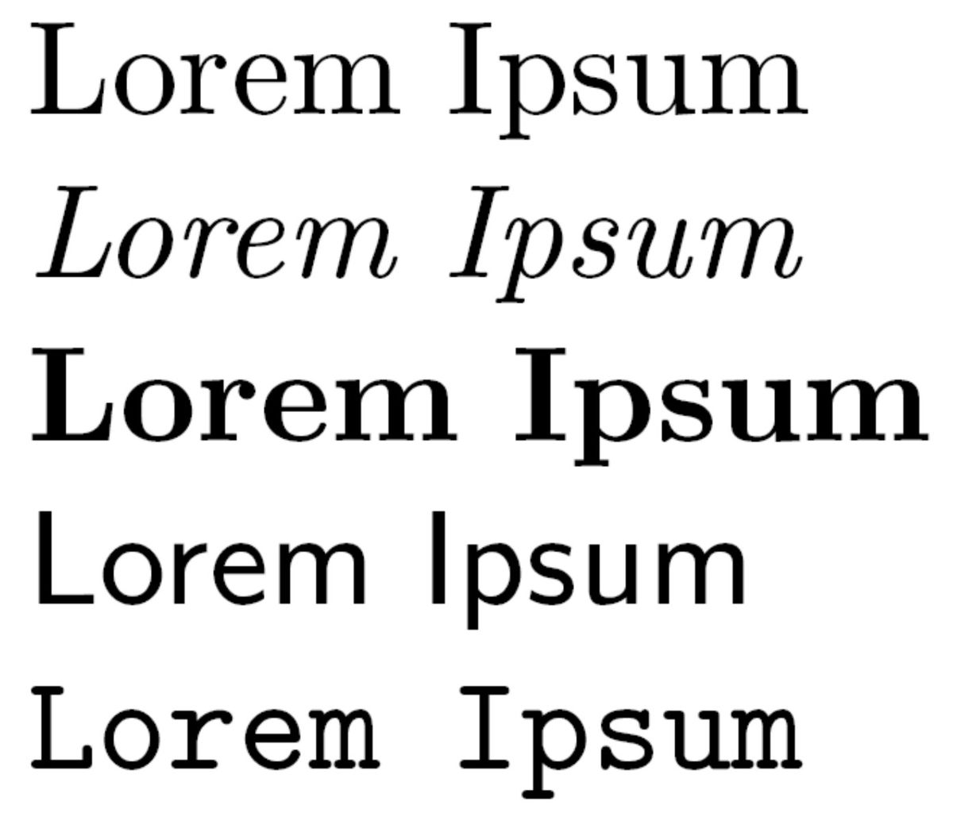
Source: Lorem ipsum dolor sit amet

Lorem ipsum dolor sit amet, consectetur adipisicing elit, sed do eiusmod tempor incididunt ut labore et dolore magna aliqua. Ut enim ad minim veniam, quis nostrud exercitation ullamco laboris nisi ut aliquip ex ea commodo consequat. Duis aute irure dolor in reprehenderit in voluptate velit esse cillum dolore eu fugiat nulla pariatur. Excepteur sint occaecat cupidatat non proident, sunt in culpa qui officia deserunt mollit anim id est laborum.

- Conclusions

Lorem ipsum dolor sit amet, consectetur adipisicing elit, sed do eiusmod tempor incididunt ut labore et dolore magna aliqua. Ut enim ad minim veniam, quis nostrud exercitation ullamco laboris nisi ut aliquip ex ea commodo consequat. Duis aute irure dolor in reprehenderit in voluptate velit esse cillum dolore eu fugiat nulla pariatur. Excepteur sint occaecat cupidatat non proident, sunt in culpa qui officia deserunt mollit anim id est laborum. Lorem ipsum dolor sit amet, consectetur adipisicing elit, sed do eiusmod tempor incididunt ut labore et dolore magna aliqua. Ut enim ad minim veniam, quis nostrud exercitation ullamco laboris nisi ut aliquip ex ea commodo consequat. Duis aute irure dolor in reprehenderit in voluptate velit esse cillum dolore eu fugiat nulla pariatur. Excepteur sint occaecat cupidatat non proident, sunt in culpa qui officia deserunt mollit anim id est laborum. Lorem ipsum dolor sit amet, consectetur adipisicing elit, sed do eiusmod tempor incididunt ut labore et dolore magna aliqua. Ut enim ad minim veniam, quis nostrud exercitation ullamco laboris nisi ut aliquip ex ea commodo consequat. Duis aute irure dolor in reprehenderit in voluptate velit esse cillum dolore eu fugiat nulla pariatur. Excepteur sint occaecat cupidatat non proident, sunt in culpa qui officia deserunt mollit anim id est laborum. Lorem ipsum dolor sit amet, consectetur adipisicing elit, sed do eiusmod tempor incididunt ut labore et dolore magna aliqua. Ut enim ad minim veniam, quis nostrud exercitation ullamco laboris nisi ut aliquip ex ea commodo consequat. Duis aute irure dolor in reprehenderit in voluptate velit esse cillum dolore eu fugiat nulla pariatur. Excepteur sint occaecat cupidatat non proident, sunt in culpa qui officia deserunt mollit anim id est laborum.

References

Books:
Surname, Name Initials (year) Title, Place of publication: Publisher.
Example:
Callicott, J. B. (1994) Earth’s Insights: A Survey of Ecological Ethics from the Mediterranean Basin to the Australian Outback, Berkeley: University of California Press.

Example if there are two or three authors:
Riddersträle, J., Nordström, K. (2004) Karaoke Capitalism Management for Mankind, Harlow: Pearson Education Ltd.

Example if there are four or more authors (the first author’s surname is followed by “et al.”):
Norton, M. B. et al. (1981) A People and a Nation - A History of the United States, Boston: Houghton Mifflin Company.

Journals:
Surname, Name Initials (year) “Title”, Journal, Volume, Number, pages.
Example:
Kostelich, E. (1995) “Symphony in Chaos”, New Scientists, Vol. 146, No. 1972, pp. 36-39.

Example if there are two or three authors:
Bovenberg, L., Sørensen, P. B. (2009) “Optimal Social Insurance with Linear Income Taxation”, The Scandinavian Journal of Economics, Vol. 111, No. 2, pp. 251-275.

Example if there are four or more authors (the first author’s surname is followed by “et al.”):
Di Noia, C. et al. (1999) “Should Banking Supervision and Monetary Policy Tasks be Given to Different Agencies?”, International Finance, Vol. 2, No. 3, pp. 285-361.

Example if there are multiple journal papers by the same author published in the same year (letters “a”, “b”, “c”, etc. are used after the year):
Quah, D. T. (1993a) “Empirical Cross-section Dynamics in Economic Growth”, European Economic Review, Vol. 37, No. 2-3, pp. 426-434.
Quah, D. T. (1993b) “Galton’s Fallacy and Tests of the Convergence Hypothesis”, Scandinavian Journal of Economics, 95, Vol. 95, No. 4, pp. 427-443.
Quah, D. T. (1994) “Exploiting cross Section Variation for Unit Root Inference in Dynamic Data”, Economics Letters, Vol. 44, No. 1-2, pp. 9-19.
Quah, D. T. (1996a) “Regional Convergence Clusters across Europe”, European Economic Review, Vol. 40, No. 3-5, pp. 951-958.
Quah, D. T. (1996b) “Empirics for Economic Growth and Convergence”, European Economic Review, Vol. 40, No. 6, pp. 1353-1375.

The author should provide Digital Object Identifier (DOI) for each reference that can be found whether it exists at CrossRef http://www.crossref.org/ and DOI appears in the form such as: http://dx.doi.org/10.1016/j. jbusvent.2010.01.002.

DOI is inserted by the author at the end of references as shown in the example as follows:
Hall, J.K., Daneke, G.A., Lenox, M.J. (2010) “Sustainable Development and Entrepreneurship: Past Contributions and Future directions”, Journal of Business Venturing, Vol. 25, No. 5,
pp. 439-448, doi: http://dx.doi.org/10.1016/j.jbusvent.2010.01.002.

Internet sources:
Author’s/editor’s surname (year), “Title of the article”, Title of the journal [type of medium], date of publication, volume number, pagination or online equivalent, <availability statement> [date of accession if necessary].

Example:
Martin, C.L. (1998) “Relationship Marketing: a High-Involvement Product Attribute Approach”, Journal of Product and Brand Management [Internet], Vol. 7, No. 1, pp. 6-26. Available at:
<http://www.apmforum.com/emerald/marketing-research-asia.htm> [Accessed: October 3, 2002]

Chapter/Section from a book of collected writings:
Author of the Chapter/Section (year of publication) “Title of the Chapter/Section”. In Author/Editor of collected work, Title of collected works, Place of publishing: Publisher.

Example:
Porter, M.A. (1993) “The modification of method in researching postgraduate education”. In Burges, R.G. ed., The research process in educational settings: ten case studies, London: Falmer.

Conference papers from Conference proceedings:
Author of the conference paper (year of publication) “Title of the conference paper”. In Title of conference proceedings. Place of publication: Publisher, pagination of section referred to.

Example:
Fedchak, E., Duvall, L. (1996) “An engineering approach to electronic publishing”.
In Proceedings of the International Workshop on Multimedia Software Development, 25-26 March, Berlin, Los Alimos, Ca: IEEE Comput. Soc. Press, pp. 80–88.

Theses and Dissertations:
Author’s name (year) Title of Thesis/Dissertation, Type of Thesis/Dissertation, name of the institution.
Example:
Whitehead, S.M. (1996) Public and private men: masculinities at work in education management, PhD Thesis, Leeds Metropolitain University.

Official publications:
Title of publication/organisation/institution (year) Title, Place of publishing: Publisher.
Example:
Department of the Environment (1986) Landfilling wastes, London: HMSO.

Laws & Regulations:
Acts of Parliament (National Laws)
Country/Government Body (Year) ‘Title of Act’ (Act Number). Source (if published officially). Available at: URL (Accessed: Date).

Example:
United Kingdom (1998) ‘Human Rights Act’ (c. 42). Available at: https://www.legislation.gov.uk/ukpga/1998/42/contents (Accessed: 12 June 2024).

EU Regulations/Directives
European Union (Year) ‘Title of Regulation/Directive’ (Regulation/Directive Number). Official Journal of the European Union, Issue, pp. Page Range. Available at: URL (Accessed: Date).

Example:
European Union (2016) ‘General Data Protection Regulation (GDPR)’ (Regulation (EU) 2016/679). Official Journal of the European Union, L 119, pp. 1–88. Available at: https://eur-lex.europa.eu/eli/reg/2016/679/oj (Accessed: 12 June 2024).

Position, University, Faculty, Street, Postal_Code City, Country. Scientific affiliation: affiliation1, affiliation2, affiliation3. Phone: +Country_Code Area_Code Phone_Number. E-mail: address@domain.extension(s).
Position, University, Faculty, Street, Postal_Code City, Country. Scientific affiliation: affiliation1, affiliation2, affiliation3. Phone: +Country_Code Area_Code Phone_Number. E-mail: address@domain.extension(s).
Position, University, Faculty, Street, Postal_Code City, Country. Scientific affiliation: affiliation1, affiliation2, affiliation3. Phone: +Country_Code Area_Code Phone_Number. E-mail: address@domain.extension(s).

